* 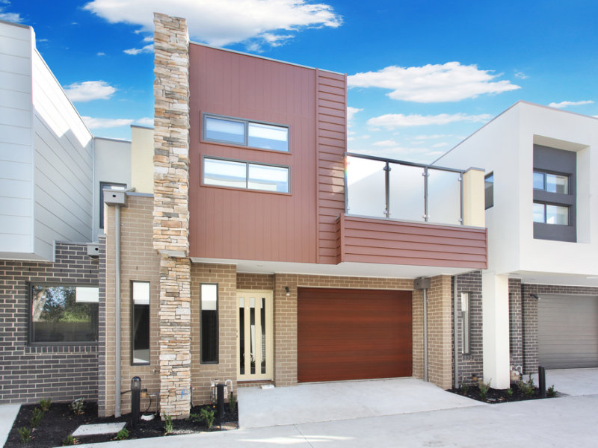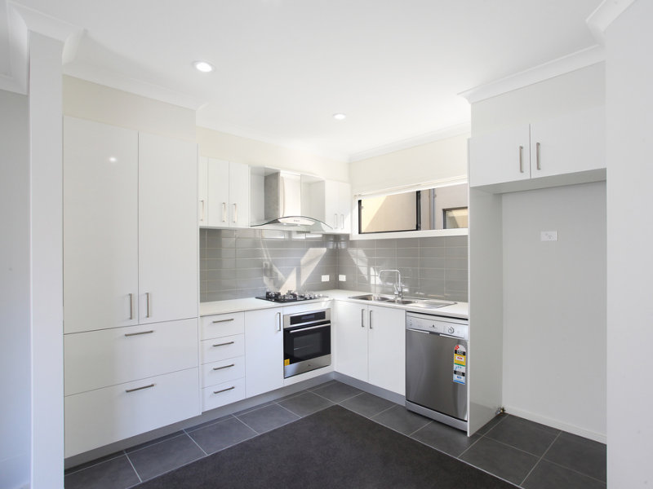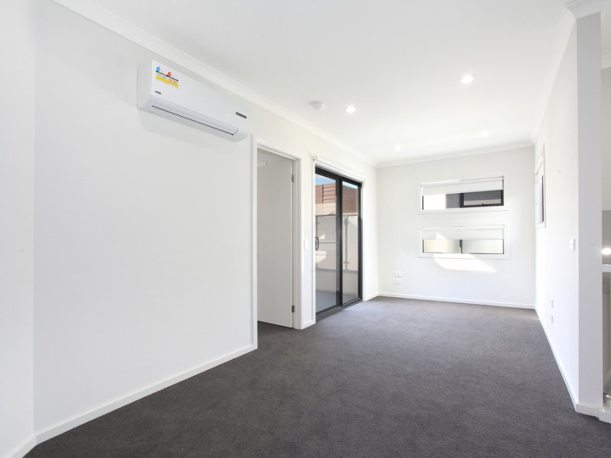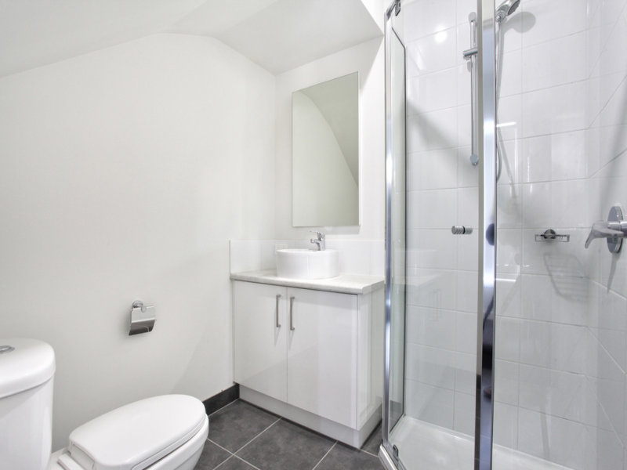cFeatures:   
  - 2 bedrooms with built in mirror wardrobes  
  - 2 bathrooms  
  - 2 toilets  
  - 2 showers  
  - Air Conditioning   
  - Heating  
  - Solar Heating in each room   
  - Remote Control Garage,   
  - Well Equipped Kitchen with dishwasher, Electric Oven, Gas Cooktop,   
  - Tv antenna point in 2 rooms  
  - Balcony/ bbq area
* $569 per week